Sample Problems: Import Tariffs and Quotas

1. Suppose Home is a **large country** whose supply and demand curves are given by the following figure.

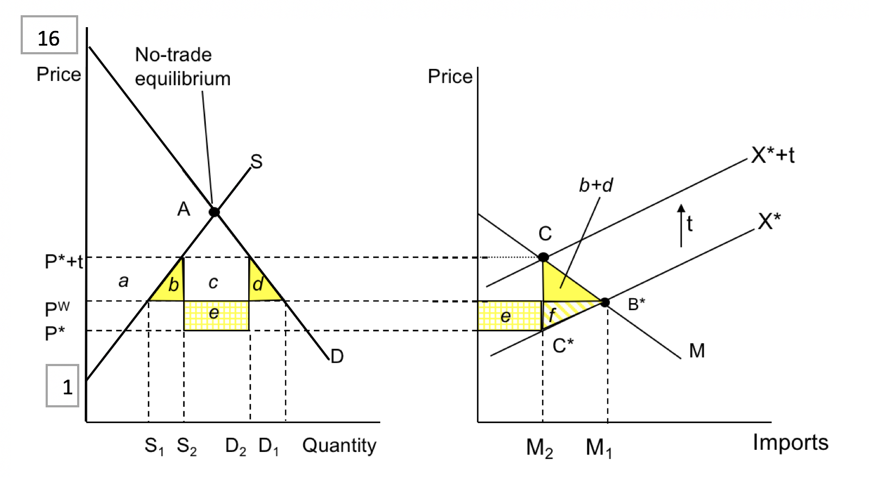

At no trade equilibrium, p =8, q=7

Pw = 5, S1 = 4, D1= 12

P* = 3

P* + t = 7, S2 = 6, D2 = 8

M1= 8, M2= 2

1. Assume the world price is PW = $5. Determine the consumer and producer surplus under free trade.
2. Suppose the government at Home government imposes a tariff in the amount of $4 (i. e. , t = $4). What is the new Home price? What is the price received by the foreign exporters?
3. Determine the terms of trade for Home with the tariff.
4. Does Home welfare increase or decrease due to the tariff? Explain.
5. Aoslia is a **small country** that takes the world price of corn as given. Its domestic supply and demand for corn is given by the following:

D =45 - 3P

S = 3P + 9

Suppose the Aoslian government applies an import quota that limits imports to 12 bushels.

1. Determine the quantity demanded, quantity supplied, and new domestic price **with the quota.**
2. Calculate the quota rent.
3. Assuming that the quota licenses are allocated to domestic producers, what is the net effect of the quota on Aoslia’s welfare?
4. Assuming that the quota rents are earned by foreign exporters, what is the net effect of the

quota on Aoslia’s welfare?

1. Consider the following hypothetical information pertaining to a country’s imports, consumption, and production of T-shirts following the removal of the MFA (Multi Fibre Arrangement) quota:

|  |  |  |
| --- | --- | --- |
|  | With MFA Quota | Without MFA (Free Trade) |
| World Price ($/shirt) | 2 | 2 |
| Domestic Price ($/shirt) | 2.5 | 2 |
| Domestic Consumption (million shirts/year) | 100 | 125 |
| Domestic Production (million shirts/year) | 75 | 50 |
| Imports (million shirts/year) | 25 | 75 |

1. Graph the effects of the quota removal on domestic consumption and production.
2. Determine the gain in consumer surplus from the removal of the quota.
3. Determine the loss in producer surplus from the removal of the quota.
4. Calculate the quota rents that were earned under the quota
5. Determine how much the country has gained from the removal of the quota.